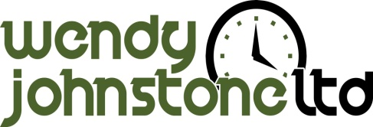
May 2017
My Success Story
As you will all know well, it’s not easy being a small business owner though about 12 months ago I made the brave decision to start working with a Business Coach. You only know what you know and there isn’t anyone to help and support you when things go wrong. I have had a tough 9 months and have probably had to tackle every business challenge possible along with suffering ill health, though when it’s only you, you have to just put on a smile and get on with it. I know that without my Business Coach Jayne Bratton by my side, I wouldn’t have made it and between us we have evolved my business so that it’s ready for the next part of the journey, to grow and flourish.
With Jayne’s help I am very excited to have been confirmed as one of the finalists for three prestigious business awards, the Hertfordshire Chamber of Commerce Inspiring Hertfordshire Award for Most Promising New Business, the SME Hertfordshire Award for Entrepreneur of the Year and North Herts Business of the Year.
This got me thinking that I would love to give something back to the business community who have supported me over the last 2.5 years.
My Exciting Offer to You…….
Your support means such a lot to me, so to celebrate this massive achievement I am offering 10 Ideas and Support sessions, which usually retails at £250 + VAT totally free of charge!!
You may be thinking “what’s an Idea’s and Support session……???”
Well, do you dream of someone giving you back more time, do you go away on holiday and take your business with you and as much as you love what you do, you wonder if there is a way to get a better work life balance?
Do you want to develop a strong foundation to be able to grow your business and take it to the next level, are you hungry to build on the success that you have had and build an even better life for you and your family?
If you are sat there thinking “yes, this is me”, then get in touch today.
How to Apply…..
If you are interested in being considered for this amazing offer then email me at wendy@wendyjohnstoneltd.co.uk. Don’t leave it too long, applications will close on Friday 30th June 2017.

