Ready to plan for your business to be business social?

Social media is no longer the buzz word for you to include in your businesses digital marketing, it should now be a part of the mix and a prominent part of your growth strategy. It’s a great way to promote your business and engage with potential customers, suppliers and contacts, new and old and for a relatively low cost. Time is the major cost factor to remember with social media and how much you spend on this can of course affect your bottom line.

Here are our top tips on making the best use of your time with social media for your business.

- Do your competitor research
When starting with your business social media, the first thing to do after sitting down with your cup of coffee is to do your competitor research. Use this early planning to gain an understanding on what your competitors are doing with their social media. What platforms are they using, where is their biggest following and what seems to provide the most conversations for their business? Look local and national with this. Often the big national competitors can inspire you on the “art of the possible” if you had unlimited time and budgets to spend on this one aspect of your business. Review your research every three-six months to make sure your social media stays active and relevant.

- You don’t have to use them all.

There are many different platforms Facebook, LinkedIn, Twitter, Pinterest, Instagram, Google + etc. and smaller niche/industry ones. To decide which platforms your business should use ask yourself two questions:
- Where will I find my audience?
- How many platforms do I have time to manage and keep active?

Depending on your business type and from your competitor research you will uncover which platforms are used by your audience and potential new customers.
For example, if you’re a teacher or craft business, you may want to use Pinterest to find boards with craft ideas and suppliers to help when planning lessons or to sell your handmade gifts.

Here is a useful little grid of the top few social media platforms to help you find your audience.

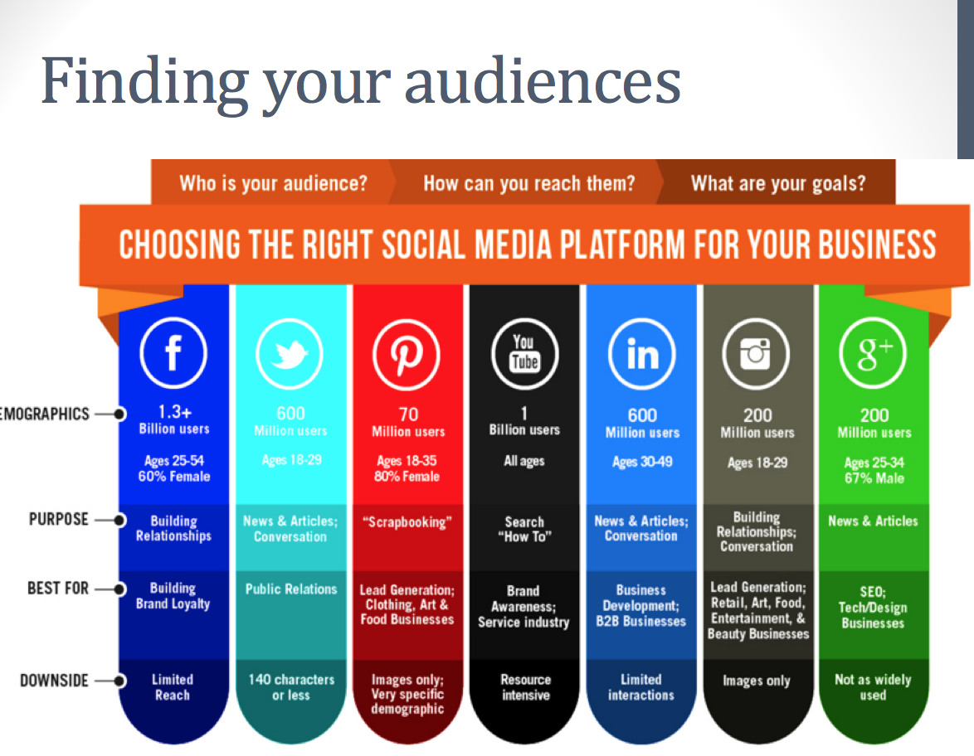

< Source of graphic - http://us.accion.org/business-resources/articles-videos/choosing-right-social-media-platform-your-business >

- Be consistent

A major factor to realise early on with your business social / marketing strategy is to be selective about which platforms you will use. Your business needs to post regularly and engage with your audience to grow your following and presence online. Be realistic, how much time do you have to spend on social media every day? Is it 30mins at lunch time or one hour once a week? Posting 3 times a day and then nothing for a few months is not a good way to grow your following and you will lose your audience. It’s all about the momentum and keeping it going. Don’t start something if you can’t keep it up. Posting online leaves a digital footprint and you want to keep it as up to date as possible so that when new clients do their research on your business they see you are relevant and still in business.

So what’s the secret with being successful on social media? Plan and schedule your social media.

Social media can be time-consuming if you let it. We know you have many aspects of your business to carry out and you don’t want social media to take over. We recommend you plan and schedule in your quiet times, so your social media remains active no matter how busy you are.

We like to use an editorial calendar where we plan a month in advance for our client’s social media messages including what events will be happening in that month, meetings they are attending that their audience needs to know about, book signings, speaking at conferences, training seminars and more! We write the posts then you can add a calendar reminder in your diary to post them in the time you have allocated to social media for your business.

The planning takes the time at the start of the month in order to free your time up later in the month.

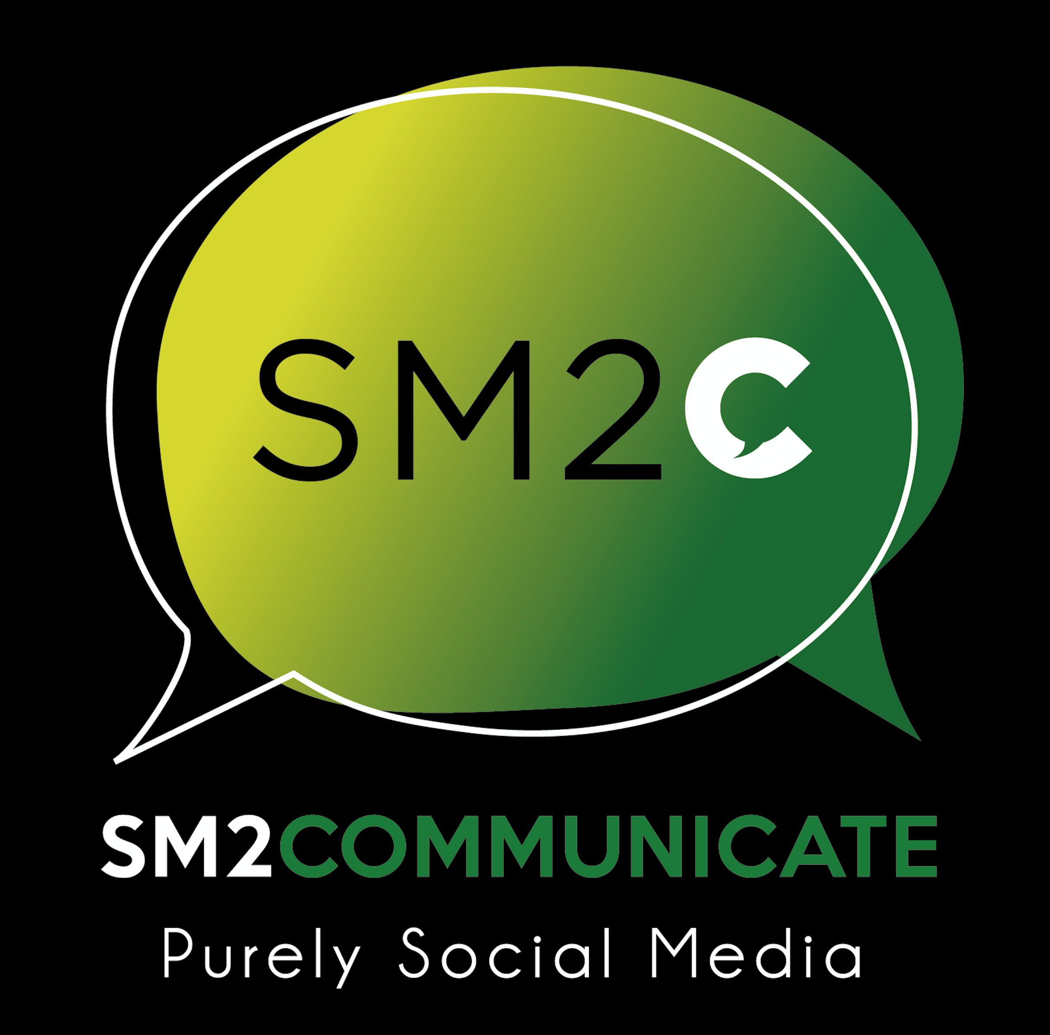

About SM2COMMUNICATE
Founded in 2012, SM2COMMUNICATE is a social media agency based in Bedfordshire. They specialise in social media and manage a variety of social media accounts on behalf of a wide range of clients. They also provide training on social media and support for new business start-ups with their social media strategy and planning.

If you’d like to get in touch please email us at info@sm2communicate.co.uk

